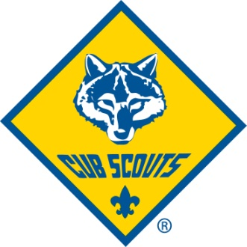
Cub Scout Pack 302
2016 Registration

Scout Name ________________________________________ Nickname _________________
School _____________________ Grade (Fall) _____ Lion Tiger Wolf Bear Web I Web II
Address __________________________________City ___________________Zip __________
Parent/Guardian Name _________________________________________________________
Phone _________________________________ Cell __________________________________
Email ________________________________________________________________________

Parent/Guardian Name #2 ______________________________________________________
Phone _________________________________ Cell __________________________________
Email ________________________________________________________________________

2016 BSA Registration Fee (new scouts only prorated Sept–Dec 2016 @$2 per month=$8) $ ___________
2017 BSA Registration Fee & Pack Dues ($70, $50 for Webelos II, $20 for Lions) $ ___________
Boy’s Life magazine subscription (recommended; $1 per month=$12) $ ___________
Optional Pack Donation (optional; helps fund camp scholarship & other pack events) $ ___________
T-shirt/hoodie order (new scouts receive one fee pack T-shirt)

 |  | Size (note quantity below)
Youth | Price | XS | Small | Medium | Large | XL | Item Total
Youth T-Shirt  (new scouts get 1 For free) | $12 |  |  |  |  |  | $
Youth Zip Hoodie | $30 |  |  |  |  |  | $

Adult | Price | Small | Medium | Large | XL | XXL  ($2 extra) | Item Total
Women’s T-Shirt | $12 |  |  |  |  |  | $
Adult Unisex T-Shirt | $12 |  |  |  |  |  | $
Adult Zip Hoodie | $32 |  |  |  |  |  | $

T-Shirt/Hoodie Total $ ___________
Total $ ___________
Make checks payable to Pack 302 or pay with a credit card

Paperwork
BSA Youth Application
Health form A&B

